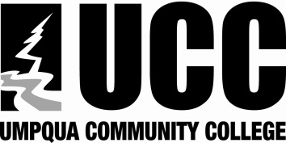
Assessment Method

Intended Course Learner Outcomes

Related Universal Outcomes

UCC’s Mission: Umpqua Community College provides high quality college degree programs, workforce development, and community learning opportunities.
Related AA/OT Outcomes

Division:
Department:
Program/Area of Emphasis:
Course Title:

Course Goal:
Date:
Course

Core Theme Two: Supporting Quality Learning and Achievement through Academic Transfer Education
COURSE OUTCOMES GUIDE

Program Outcomes
Universal Outcomes:
Students who complete programs at UCC will:

- Exhibit professional skills and standards that will lead to workplace or continued academic success.

- Communicate effectively by applying appropriate listening, speaking, and writing skills both individually and as a member of a team.

- Demonstrate satisfactory academic knowledge appropriate to their educational goals.

- Identify and articulate ethical issues as they apply to personal and professional choices.

- Contribute the positive welfare of the campus, local, and broader community through engaging in diverse, cross-cultural opportunities and interactions.

- Demonstrate appropriate use of current technology as it relates to their programs of study.

- Identify professional goals that support lifelong learning, productivity, and satisfaction.

