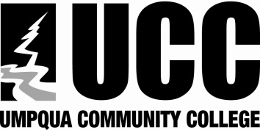
Date: Click here to enter a date.
Course #:
Click here to enter text.

COURSE OUTCOMES GUIDE
Intended Course Learner Outcomes

By the end of this course, students will:

Assessment Method

Correlated Program
Outcomes

Correlated Institutional Outcomes

Division: Choose an item.
Department: Click here to enter text.
Program/Area of Emphasis:Click here to enter text.
Course Title: Click here to enter text.

Course Goal:
Core Theme Choose an item.
UCC’s Mission: Umpqua Community College provides high quality college degree programs, workforce development, and community learning opportunities.

Program Outcomes:
- Enter outcomes here

Institutional Outcomes:
Students at UCC will:

- Exhibit professional skills and standards that will lead to workplace or continued academic success.

- Communicate effectively by applying appropriate listening, speaking, and writing skills both individually and as a member of a team.

- Demonstrate satisfactory academic knowledge appropriate to their educational goals.

- Identify and articulate ethical issues as they apply to personal and professional choices.

- Demonstrate good citizenship through respect, tolerance, and cultural awareness.

- Demonstrate appropriate use of current technology as it relates to their programs of study.

- Integrate consistent lifelong learning for personal and professional development.

